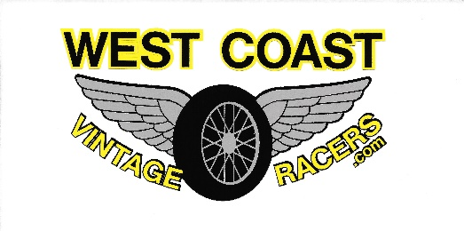
2022 Race Schedule
Hermiston Raceway, Hermiston, OR
May 13 – Practice
May 14 – Racing

Stateline Speedway, Post Falls, ID
June 10 – Practice
June 11 – Racing

Mission Valley Super Oval, Polson, MT
June 24 – Racing
June 25 – Racing

Wenatchee Valley Super Oval, East Wenatchee, WA
July 15 – Practice
July 16 – Racing

Evergreen Speedway, Monroe, WA
August 12 – Practice
August 13 – Racing

Agassiz Speedway, Agassiz, BC
September 8 – Practice & BBQ
September 9 – Racing
September 10 – Racing

Meridian Speedway, Meridian, ID
September 22 – Practice
September 23 – Racing
September 24 - Racing

